
YENEPOYA INSTITUTE OF ARTS, SCIENCE,
COMMERCE AND MANAGEMENT

Low Level Design (LLD)

Anomaly Detection of Retail Transactions

Student Name: Aleema Naba Ks
Register Number: 23BSAMD005
Course: BSc Artificial Intelligence, Machine Learning and Data Science

Industry Mentor: Mr. Sumit Kumar Shukla
Guided By: Fathimath Raheema

Table of Contents

1. Introduction

2. Detailed Module Design

3. Algorithm Design

4. Data Structures

5. Function-Level Design

6. Error Handling

7. Interface Design

8. Performance Considerations

9. References

1. Introduction

1.1 Scope of Document

This document describes the detailed internal design of the anomaly detection system, including modules, algorithms, and data handling processes.

1.2 Intended Audience

• Developers
• Evaluators
• Project reviewers

1.3 System Overview

The system is a web-based application used to detect anomalous retail transactions using statistical methods such as Z-Score and an optional machine learning model (Isolation Forest). It allows users to upload transaction data, analyze anomalies, visualize results, and download reports.

2. Detailed Module Design

2.1 Modules

1. Input Module

• Accepts CSV file upload
• Accepts threshold value (1–5)
• Validates user input

2. Data Processing Module

• Reads CSV using Pandas
• Extracts numeric columns
• Cleans and prepares data

3. Anomaly Detection Module

• Calculates mean and standard deviation
• Applies Z-Score method
• Detects anomalies based on threshold
• Uses Isolation Forest model (optional)

4. Visualization Module

• Generates charts:
• Line graph
• Trend line
• Histogram
• Saves charts as images

5. Output Module
• Displays total transactions and anomalies
• Shows average score and selected column
• Displays anomaly table
• Provides CSV download option
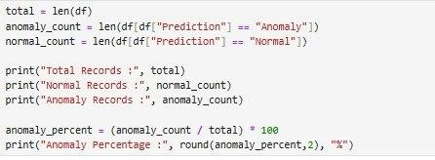

3. Algorithm Design

3.1 Anomaly Detection Algorithm

Steps:
1. Accept CSV file from user
2. Load dataset using Pandas
3. Identify numeric column
4. Compute mean (µ) and standard deviation (σ)
5. Calculate Z-Score for each value
6. Compare with threshold
7. Mark anomalies if |z| > threshold
8. Return results

3.2 Z-Score Formula

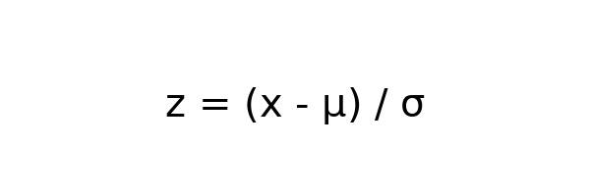
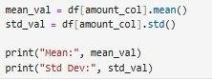

3.3 Machine Learning Approach

• Load pre-trained Isolation Forest model
• Predict anomalies
• Output:
• -1 → anomaly
• 1 → normal

4. Data Structures
Data | Structure
Dataset | Pandas DataFrame
Columns | List
Result | DataFrame
Output | Dictionary

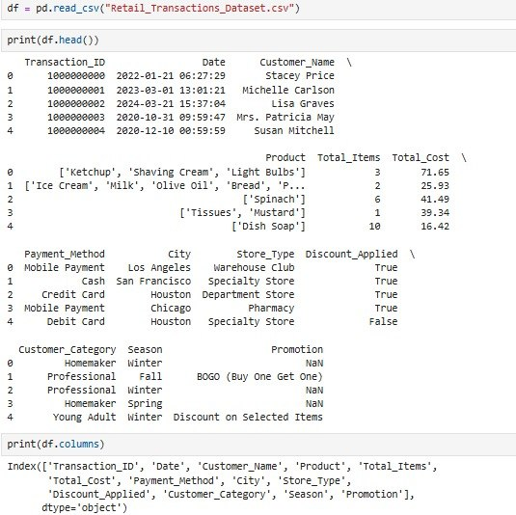

5. Function-Level Design

• load_data() → Loads CSV file
• preprocess_data() → Cleans dataset
• calculate_zscore() → Computes Z-Score
• detect_anomalies() → Filters anomalies
• generate_charts() → Creates graphs
• download_report() → Exports CSV
• main_controller() → Controls workflow

6. Error Handling

• Invalid file → error message displayed
• Missing numeric data → handled
• Division by zero → handled
• No anomalies found → fallback output
• Missing model → uses Z-Score

7. Interface Design

7.1 User Interface

• Web dashboard
• File upload form
• Threshold slider
• Charts and table display

7.2 Output Interface

Displays:
• Total transactions
• Anomaly count
• Average score
• Charts
• Downloadable report

8. Performance Considerations

• Uses in-memory processing
• No database required
• Fast execution using Pandas
• Optimized chart generation

9. References

• Flask Documentation
• Pandas Documentation
• NumPy Documentation
• Matplotlib Documentation
• Scikit-learn Documentation

